Application of Deep Learning in Ship Detection Using SAR Imagery and AIS Data

Lena Chang^{1,2}, Yi-Ting Chen^{*3}, Shi-Wen Chi¹, Meng-Che Wu⁴, Yang-Lang Chang⁵
¹Lena Chang; Shi-Wen Chi, Department of Communications, Navigation and Control Engineering, National Taiwan Ocean University, Keelung, Taiwan.
Email: lenachang@mail.ntou.edu.tw; 11067003@mail.ntou.edu.tw
²Lena Chang, The Intelligent Maritime Research Center (IMRC), National Taiwan Ocean University, Keelung, Taiwan.
Email: lenachang@mail.ntou.edu.tw;
³Yi-Ting Chen, Department of Electrical Engineering, National Taiwan Ocean University, Keelung, Taiwan.
Email: 20953003@mail.ntou.edu.tw
⁴Meng-Che Wu, Taiwan Space Agency, Hsinchu, Taiwan.
Email: momo@tasa.org.tw
⁵Yang-Lang Chang, Department of Electrical Engineering, National Taipei University of Technology, Taiwan.
Email: ylchang@ntut.edu.tw

ABSTRACT: With the rapid development of maritime traffic, the automatic ship recognition can facilitate the implementation of smart ports and improve the efficiency of port operation and management. Synthetic Aperture Radar (SAR) imagery has proven useful for regular and long-term monitoring of the marine environment and ship detection due to its wide coverage. Automatic Identification System (AIS) can provide real-time ship position, course, speed and other dynamic information. In recent years, computer vision based on deep learning and convolutional neural networks (CNNs) has been widely applied in various fields, especially in object detection and classification. Compared to traditional methods, the image features extracted by deep convolutional neural networks (DCNNs) are robust to morphological changes, image noise, and relative object positions in images. Ships of various sizes and shapes can be detected by deep learning methods with higher detection accuracy than traditional methods. But it remains a challenge in detecting various orientations or densely distributed ships, especially in ports.
This study applied deep learning to ship detection using SAR images and AIS data to effectively monitor ship activities. The block diagram of the proposed ship detection method was shown in Figure 1. First, a deep learning model based on the You Only Look Once version 7 (Yolov7) architecture was applied to ship detection in SAR images. Yolov7, known for fast and accurate real-time object detection, incorporates architectural innovations such as Extended Efficient Layer Aggregation Network (E-ELAN) and model scaling based on concatenation models. Most objects have relatively small aspect ratio, and the deep learning algorithms proposed previously can be applied to most object detection. However, ships have various orientations and a relatively large aspect ratio, and traditional horizontal bounding box methods cannot provide accurate orientation and scale information. To address this issue, the oriented bounding box has been used to identify the orientation of the object and map it onto the bounding box, allowing the bounding box to enclose the object with arbitrary angles. Therefore, Yolov7 with an oriented bounding box (Yolov7-obb) was adopted to improve ship detection performance in SAR images with complex backgrounds, especially for densely arranged ships in ports. Next, the SAR Ship Detection Dataset (SSDD), which contains satellite sources with resolutions ranging from 1m to 15m, was used for the Yolov7 network to extract multi-scale and multi-type ship features. The SSDD dataset contains a total of 1160 images with image size of 500×350. In addition, the study also constructed the Taichung Ship Detection Dataset (TSDD), which consists of Sentinel-1 and Capella SAR images collected from the Taichung port area in Taiwan. There are 1000 images in TSDD, and the image size is 416×416. Moreover, the generalization ability of the ship detection model was verified by the Sentinel-1 SAR images collected in Kaohsiung port area of Taiwan, which were not included in the dataset. Then, the corresponding AIS data collected at the same location and within 6 minutes of the SAR image acquisition time were used to verify the ship detection results in the SAR image. Comparing the ship detection results in SAR with AIS data can not only verify the effectiveness of the ship detection model, but also analyse the behaviour and trajectory of ships detected in SAR images.
All experiments were performed on a PC equipped with 12 GB memory of NVIDIA GeForce RTX3080, 16 GB memory of Intel Core i7-12700kf, and using cuDNN 8.2.0 with CUDA 11.3. In this study, the ship datasets were divided into 80% training images and 20% testing images. During training, the batch size and the number of epochs were set to 32 and 1000, respectively. The Adam optimizer and Complete Intersection over Union (CIoU) loss function were selected to train the U-Net models. The learning rate was set to 0.0001 and an early stopping was set by monitoring the value of loss function. The operating system was Windows 10 64-bit. In experiments, the study compared the ship detection performance of the Yolov7 and Yolov7-obb networks using SSDD and TSDD datasets, as shown in Table 1 and Table 2. It can be seen from Table 1 that the Yolov7-obb network achieved better detection performance, and the mean Average Precision (mAP) of SSDD and TSDD datasets were 93.9% and 90.6%, respectively, which were 0.6% and 2.1% higher than the corresponding values of the Yolov7 network. Especially for ship detection in complex scenes, such as near-shore areas, the mAP of Yolov7-obb on SSDD and TSDD datasets was 77.2% and 80.3%, respectively, which was 4.6% and 4.1% higher than the Yolov7 model, as shown in Table 2. In addition, in order to verify the generalization ability of the deep learning model, the ship detection model was training by three datasets, including SSDD, TSDD and mixed datasets. The mixed dataset combined SSDD and TSDD datasets for the training of deep learning models. Three different ship training models of Yolov7-obb were further examined using SAR images acquired from Kaohsiung port, which were not included in the datasets. As shown in Table 3, the Yolov7-obb greatly improved the ship detection performance, with a mAP of 60.4%, 72.5% and 75.7%, which was 25.0%, 9.6% and 8% higher than the Yolov7 network trained by SSDD, TSDD and mixed datasets, respectively. These results validated the performance improvement of ship detection using the Yolov7-obb network, especially in inshore areas. Finally, the experiment compared the ship detection results of SAR images with the corresponding AIS data, as shown in Figure 2 and 3. The red rectangular box is the ships detected by the Yolov7-obb network, and the green circle indicates the ship position provided by the corresponding AIS data. Due to the large separation between ships in the sea area, the ship matching of SAR and AIS data is very effective. All ships detected in the T1 images matched the AIS data. Most of the ships detected in T2 matched AIS. Due to SAR resolution limitation or incorrect ship information in AIS data, some ship targets with AIS reply information were not detected in SAR (indicated by orange circles), while some ship targets detected in SAR did not have the corresponding AIS data (indicated by blue circles). T3 and T4 were the images collected from the port area. Most of the ships along the port have been matched with the corresponding AIS data. Some ship detection errors came from radar scatter of buildings and facilities along the port (showed by blue arrows in T3), and some targets were missed due to resolution limitations of SAR (showed by orange arrows in T4). Finally, the ship information, such as ship course and navigation track, can be further analysed by comparing SAR detection results with the corresponding AIS data, as shown in Figure 4. The experimental results validated that the Yolov7 network combined with the oriented bounding box can effectively improve ship detection performance, especially for ships close to the coast and densely distributed.

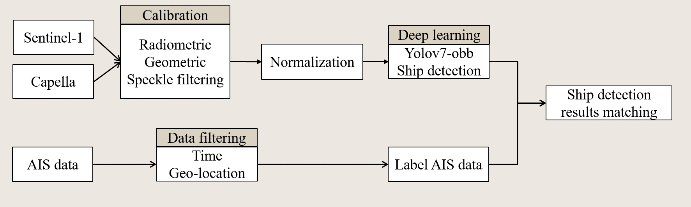
Figure 1. The block diagram of the proposed ship detection method.

Table 1. Ship detection performance on SSDD and TSDD datasets.
Dataset | Model | mAP | Precision | Recall | F1-score
SSDD | Yolov7 | 93.3% | 93% | 94% | 0.93
 | Yolov7-obb | 93.9% | 93% | 94% | 0.93
TSDD | Yolov7 | 88.5% | 88% | 86% | 0.87
 | Yolov7-obb | 90.6% | 90% | 90% | 0.90

Table 2. Near-shore ship detection performance on SSDD and TSDD datasets.
Dataset | Model | mAP | Precision | Recall | F1-score
SSDD | Yolov7 | 72.6% | 75% | 71% | 0.73
 | Yolov7-obb | 77.2% | 80% | 77% | 0.78
TSDD | Yolov7 | 76.2% | 78% | 73% | 0.75
 | Yolov7-obb | 80.3% | 82% | 81% | 0.81

Table 3. Generalization ability of the proposed ship detection model trained by three datasets using SAR images from Kaohsiung port..
Dataset | Model | mAP | Precision | Recall | F1-score
SSDD | Yolov7 | 35.4% | 77% | 36% | 0.49
 | Yolov7-obb | 60.4% | 77% | 44% | 0.56
TSDD | Yolov7 | 62.9% | 64% | 64% | 0.64
 | Yolov7-obb | 72.5% | 72% | 64% | 0.67
Mixed | Yolov7 | 67.7% | 75% | 61% | 0.67
 | Yolov7-obb | 75.7% | 78% | 66% | 0.72

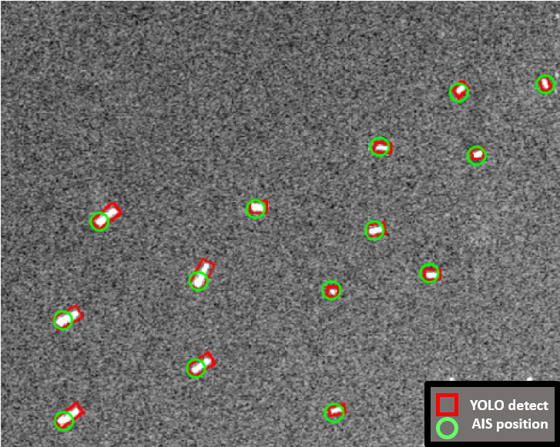 | 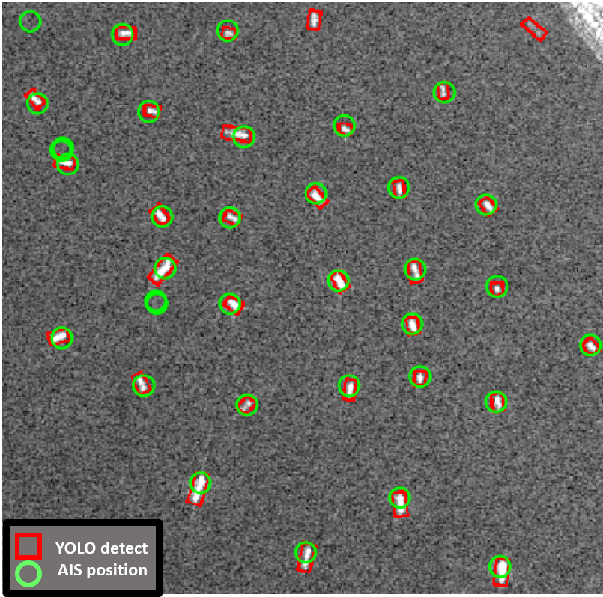
(a) T1 | (b) T2
Figure 2. Ship detection results of open sea area by Yolov7-obb with the corresponding AIS data.
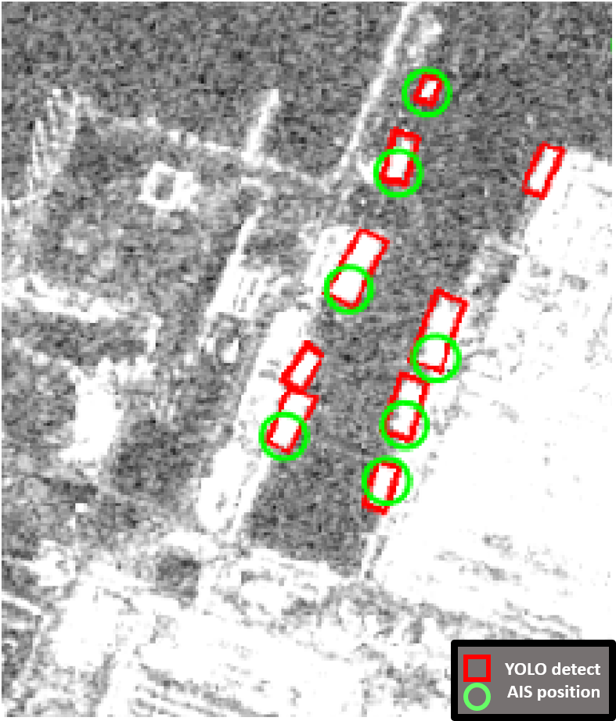 | 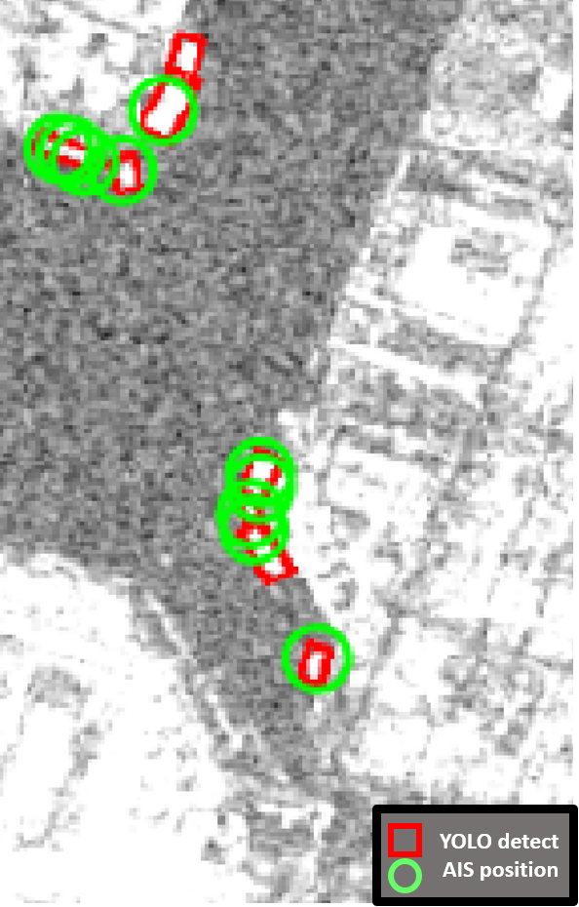
(a) T3 | (b) T4
Figure 3. Ship detection results of inshore area by Yolov7-obb with the corresponding AIS data.
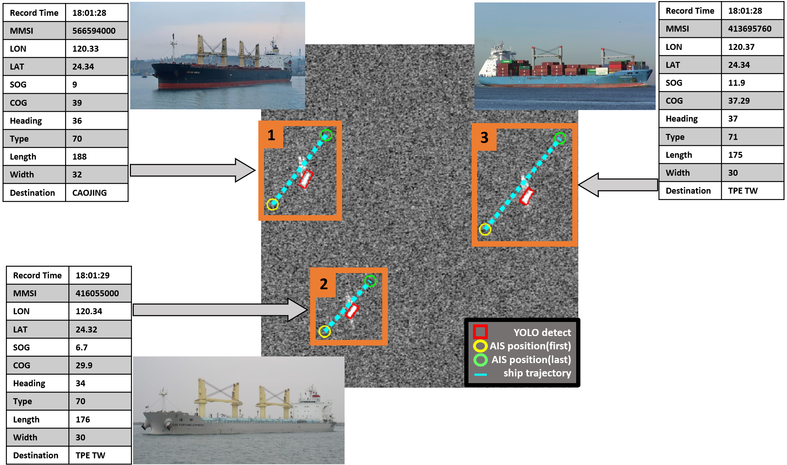
Figure 4. Combining SAR ship detection with AIS data for ships monitoring.

KEY WORDS: Synthetic Aperture Radar (SAR); Automatic Identification System (AIS); ship detection; You Only Look Once version 7 (Yolov7); oriented bounding box (OBB)

